|  |
| --- |
| Computer Engineering Department  Faculty of Engineering  Cairo University |

**Introduction to algorithms(CMPN 302)**

**Midterm Exam – 3rd Year Fall 2014**

**(1.5 hour)**

*Total Marks: 40*

**Notice**

**1. Answer all questions.**

**2. If you want to use external sheets write your name, section and BN and staple them.**

**3. Make your answers in list of points and not essay.**

|  |
| --- |
| **NAME:**  **SECTION:**  **B.N.:** |

**Question 1 (10):**

**Question 2 (10):**

**Question 3 (10):**

**Question 4 (10):**

**Total (40):**

**Question 1: [10 points]**

1. **Use the Master Theorem to solve the following recurrences. State which case of the Master Theorem you are using (and justify) for each of the recurrences**
2. **
3. **
4. **
5. **
6. **

1. **True or False? Justify your answers**
2. A heap can be constructed from an unordered array of numbers in linear worst-case time. …………………………………… **T F**
3. Merge sort has no best and worst case complexity, it is always O(n lg n). ………………………………………..……  **T F**
4. Any Dynamic Programming algorithm with n subproblems will run in O(n) time. **T F**
5. If an in-place sorting algorithm is given a sorted array, it will always output an unchanged array. **T F**
6. The sequence 20, 15, 18, 7, 9, 5, 12, 3, 6, 2is a max-heap. **T F**

**Question 2: [10 points]**

1. You are tasked to implement a database for a new telephone company. The database will contain the names and phone numbers of all its clients. For the following operation, the company wants the average running time to be small as possible: 1) insert a new entry, 2) search for a person phone number and 3) remove an entry from the database.

What data structure will you use, and what are the main design issues that you need to consider?

1. Given a sorted array of distinct integers A[1,….n].
   1. Write a recursive algorithm **Find_i** to find out whether there is an index I for which A[i]=i.
   2. Write down the recursive relation that describes the running time of your algorithm and solve it using the substitution method or the recursion tree method.

**Question 3: [10 points]**

1. Given the following list give the first 3 scans for sorting it using quicksort. Use the rightmost element as pivot.

|  |  |  |  |  |  |  |  |  |  |  |
| --- | --- | --- | --- | --- | --- | --- | --- | --- | --- | --- |
| List | 37 | 13 | 42 | 87 | 4 | 12 | 66 | 19 | 57 | 25 |
| 1st scan |  |  |  |  |  |  |  |  |  |  |
| 2nd scan |  |  |  |  |  |  |  |  |  |  |
| 3rd scan |  |  |  |  |  |  |  |  |  |  |

1. Draw the AVL tree that results from inserting the keys 7, 2, 3, 8, 16, 25, in that order into an initially empty AVL tree. **Show steps in details**

Then Give a ***Pre-order*** traversal of your final tree .

**Question 4: [10 points]**

Let x = x1,x2 . . . xn and y = y1,y2 . . . ym and z = z1,z2 . . . zn+m be three strings of length n, m, and n+m, respectively. We say that z is a merge of x and y if x and y can be found as two disjoint subsequences in z.

For 0 <= i <= n and 0 <= j <= m, Merge(i, j) is true if z = z1,z2 . . . zi+j is a merge of x = x1,x2 . . . xi and y = y1,y2 . . . yj (***x is the empty string if i = 0. Similarly for y and z.***)

We can compute Merge(i, j) using the following formula

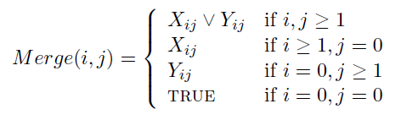

Where Xij is defined as (zi+j = xi) ^Merge(i − 1, j)

and Yij is defined as (zi+j = yj) ^Merge(i, j − 1)

This function can be implemented as follows

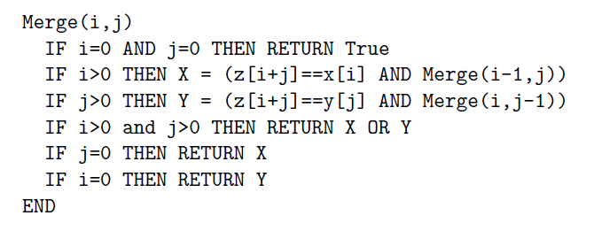

(a) Show that the running time of Merge(n,m) is exponential in n and m.

(b) Describe an O(nm) algorithm for solving the problem.